**Introduction**

Jenkins is an open-source automation server developers can use to automate building, testing, and deploying applications. It is available on a variety of systems, including Windows, Linux, Unix, and macOS.

**Install Jenkins on Windows**

1. Browse to the [official Jenkins download page](https://www.jenkins.io/download/). Under the Downloading Jenkins section is a list of installers for the long-term support (LTS) version of Jenkins. Click the Windows link to begin the download.

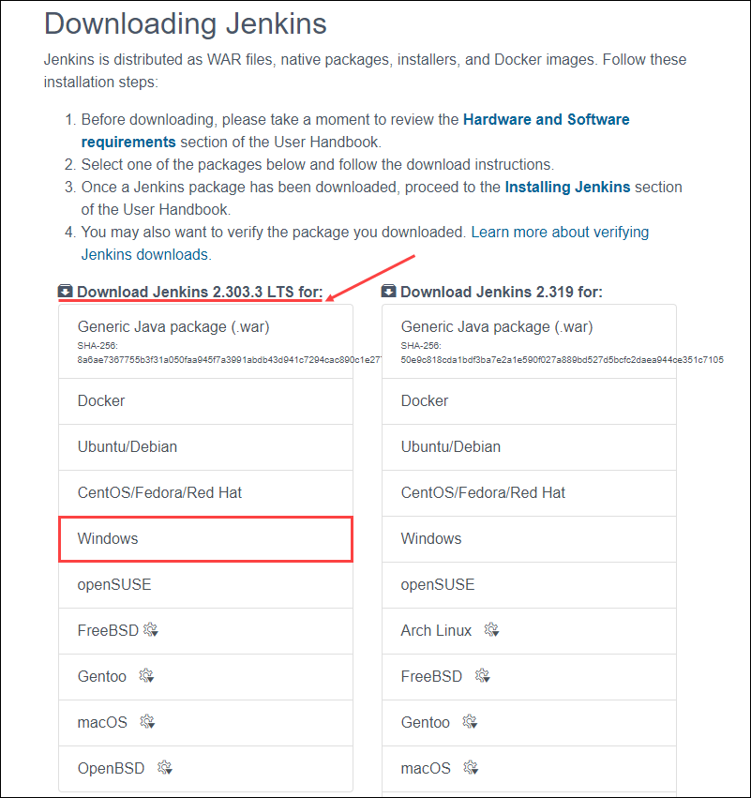

1. Once the download is complete, run the jenkins.msi installation file.
2. The setup wizard starts. Click Next to proceed.

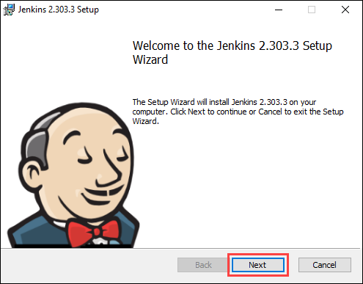

1. Select the install destination folder and click Next to continue.

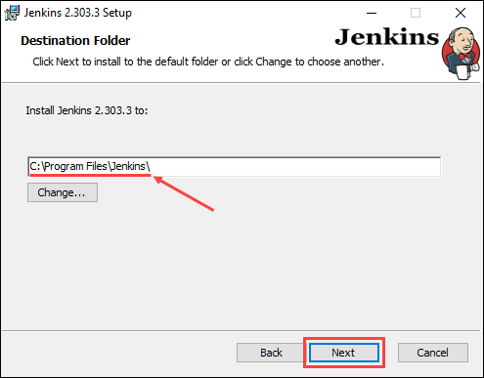

1. Under the **Run service as a local or domain** user option, enter the domain username and password for the user account you want to run Jenkins with. Click **Test Credentials** to verify the login data, then click **Next** to proceed.

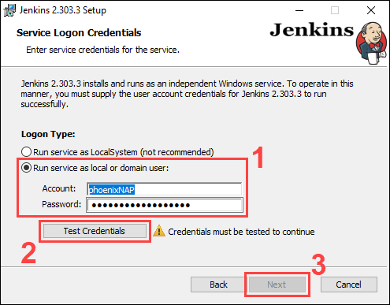

Using the **Run service as LocalSystem** option doesn’t require you to enter user login data. Instead, it grants Jenkins full access to your system and services. Note that this is a less secure option and is thus not recommended.

**Note:** When selecting the **Run service as local or domain user**, the user in question must have the required permission to log on as a service. If this is not the case, an error message stating the account cannot be verified appears. In the event of this error, perform the following steps to resolve the issue:

1. Make sure you are logged in as a user with administrative privileges.  
   2. In the **Administrative Tools**, open **Local Security Policy**.  
   3. In the **Local Security Policy** window, expand **Local Policy** in the left-hand panel and select **User Rights Assignment**.  
   4. In the right-hand side panel, right-click **Log on as service** and select **Properties**.  
   5. Click the **Add User or Group…** button.  
   6. Use the **Select Users or Groups** dialogue to add the current user and click **OK**.  
   7. Save changes by clicking the **OK** button in the **Properties** window.
2. Enter the port number you want Jenkins to run on. Click **Test Port** to check if the selected port is available, then click **Next** to continue.

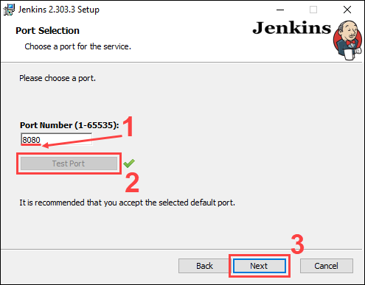

1. Select the directory where Java is installed on your system and click **Next** to proceed.

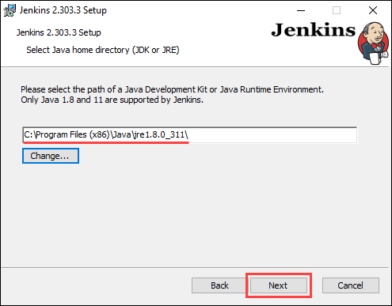

1. Select the features you want to install with Jenkins and click **Next** to continue.

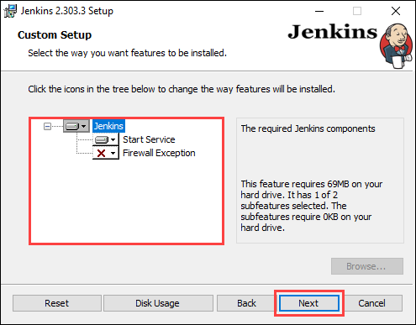

1. Click **Install** to start the installation process.

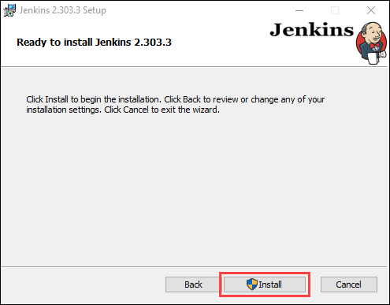

1. Once the installation is complete, click Finish to exit the install wizard.

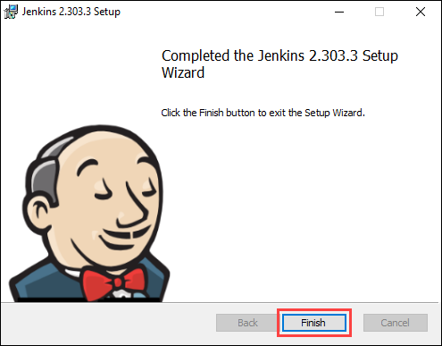

**Unblock Jenkins**

After completing the installation process, you have to unblock Jenkins before you can customize and start using it.

1. In your web browser, navigate to the port number you selected during the installation using the following address:

http://localhost:[port number]

1. Navigate to the location on your system specified by the Unblock Jenkins page.

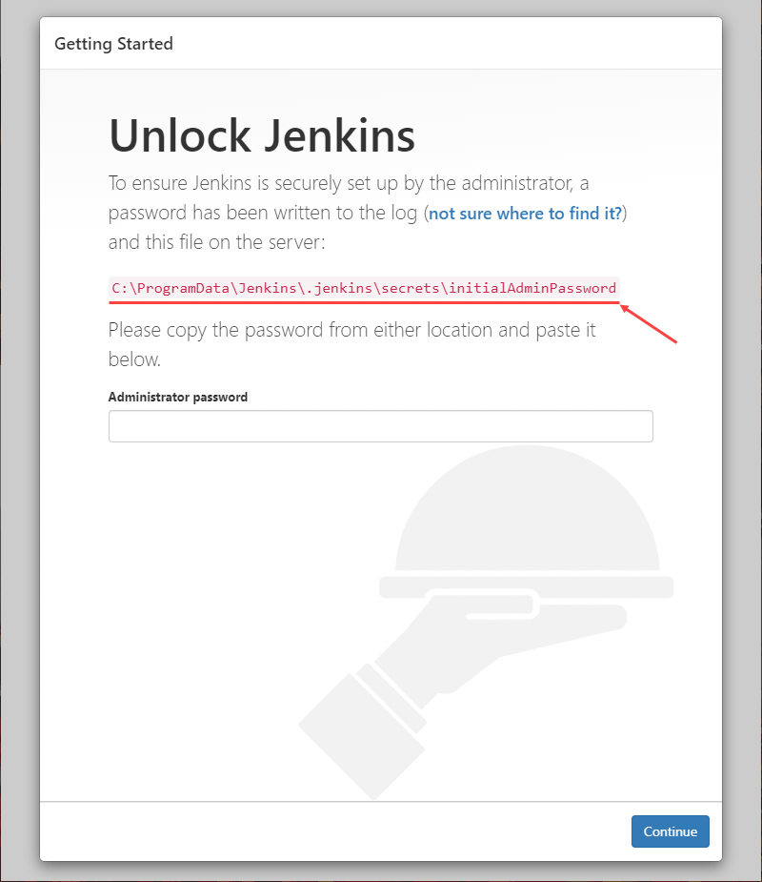

1. Open the **initialAdminPassword** file using a text editor such as Notepad.

**Note:** The Unblock Jenkins page may point to a hidden directory. In case you cannot find the directory, make sure you enable viewing hidden items.

1. Copy the password from the initialAdminPassword file.

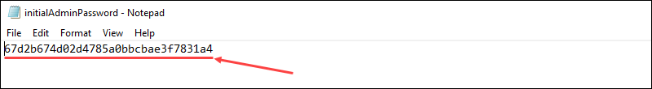

1. Paste the password in the Administrator password field on the Unblock Jenkins page and click Continue to proceed.

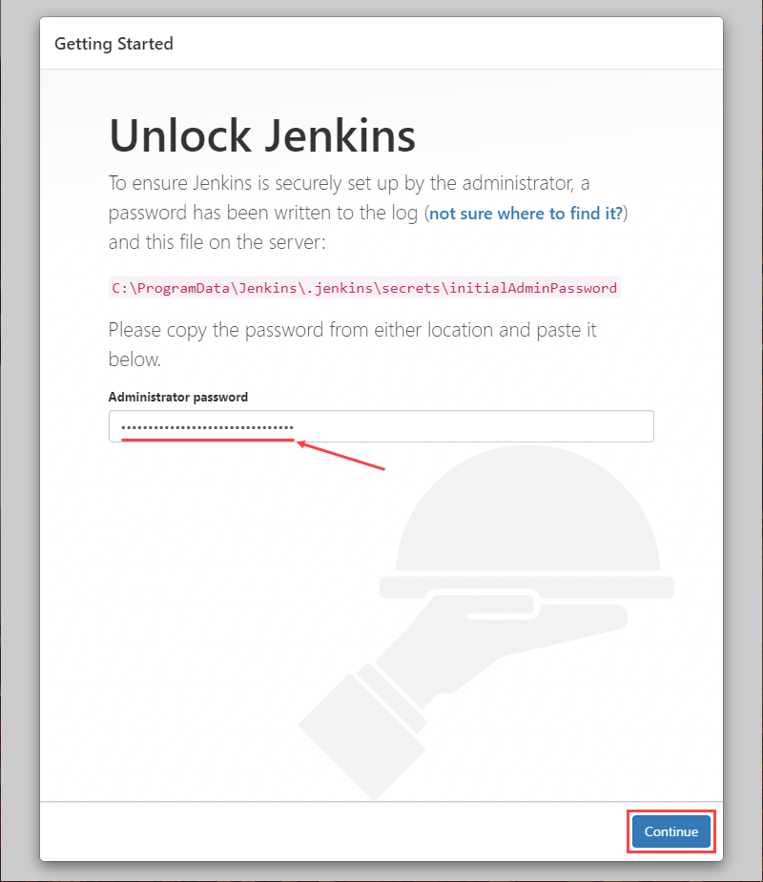

**Customize Jenkins**

Once you unlock Jenkins, customize and prepare the Jenkins environment.

1. Click the Install suggested plugins button to have Jenkins automatically install the most frequently used plugins.

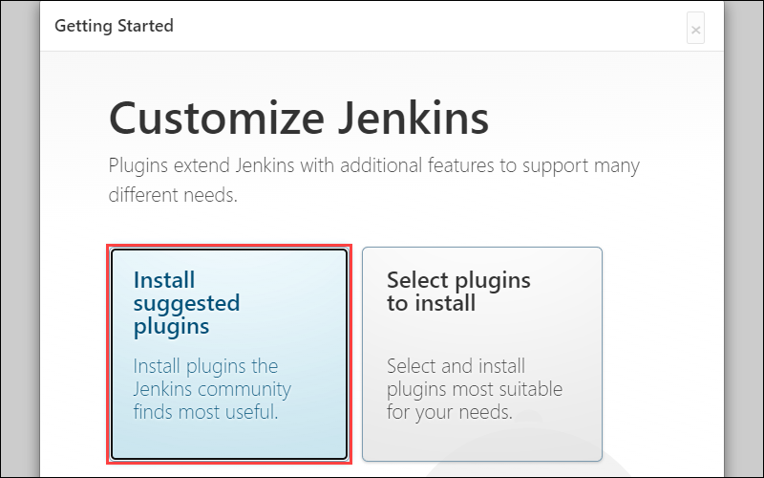

**Note:** If you are an advanced user, clicking the **Select plugins to install** button allows you to choose which plugins to install.

1. After Jenkins finishes installing the plugins, enter the required information on the Create First Admin User page. Click Save and Continue to proceed.

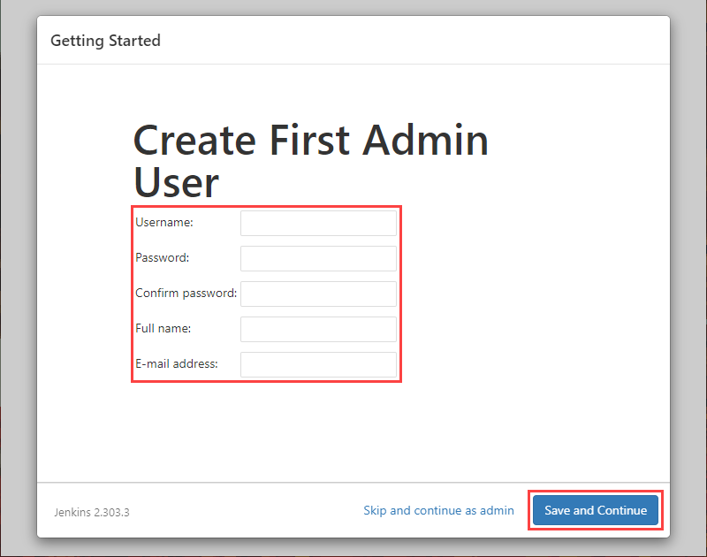

1. On the **Instance Configuration** page, confirm the port number you want Jenkins to use and click **Save and Finish** to finish the initial customization.

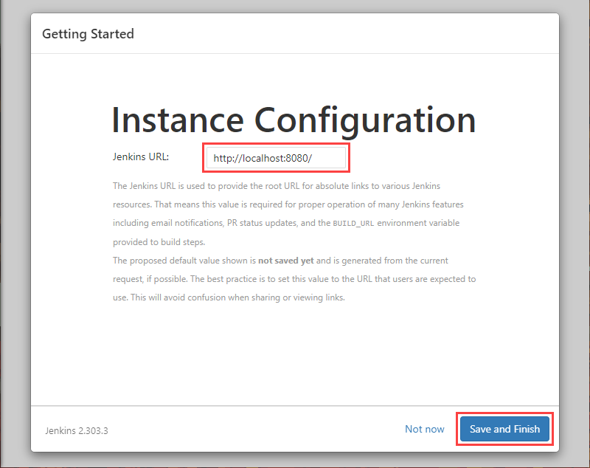

1. Click the **Start using Jenkins** button to move to the Jenkins dashboard.

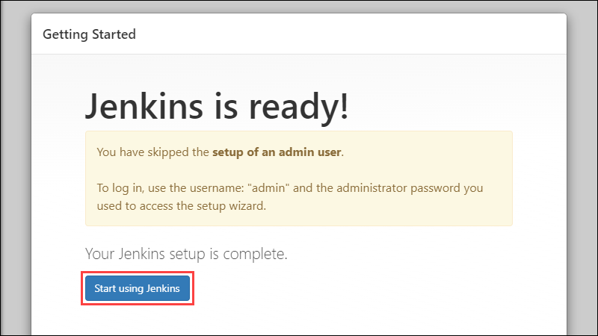

1. Using the Jenkins dashboard, click Create a job to build your first Jenkins software project.

